## **horizontal line**

Emergency SOS using centrality measure.

**26.10.2018**

**Akshat Shrivastava 16BCE0692**

**Arpan Shrivastava 16BCE2133**

**Jivjot Singh 16BCI0174**

**Naman Singh Bhandari 16BCE0733**

**Simran Koul 17BCE2210**

**Course Code: CSE3021 – Social and Information Networks**

**Slot: A1 + TA1**

**Professor: Dr. W.B.Vasanth**

# 

# INTRODUCTION

How would you know whom to contact in emergency situations ,who can spread your news to a wide number of people you trust ?  
We face a lot of situation just like this in our daily life…..but we never try to find a solution to this.

That’s why we are here to solve your problem. Our project focuses on how to manage these types of problems, whom to contact and how far these messages should deliver.

Suppose you have 2% battery in your mobile and you are in a emergency situation first question which comes to mind is “Whom would I contact so as to get maximum help?”. So basically you would need to contact a person who knows a lot of people and to whom you can trust, after contacting him you will be starting getting messages if the message number increases you will get confused ,so to avoid this you can set a number of people he/she shares. Secondly which message to read first (your most trusted)because you have a little battery left.

Our project orbits around all these situations and problems which we face daily. And as it is faced by everyone in a daily basis we can extend this project to greater means with a proper skillset.

**ABSTRACT**

This whole project is based on centrality and how it can be effectively used in daily life during emergency situations. Here , in this project, every person acts as a node. So when a person contacts an appropriate center which will multicast to different other nodes, this means that when a node will contact an appropriate center which will multicast to other nodes so that help may reach the emergency critical situation as soon as possible. The person who receives the message of the individual in need should neither have a very small group of people linked to him/her that not everyone will be aware, and neither a very large group of people resulting in denial of service . This means that an appropriate center will be one which has neither a very small centrality that not everyone who need to know wouldn't be aware, and neither a very large centrality which may result in a denial of service towards the individual in need. This centrality measure is a practical approach to problems which can be as casual as a punctured tire or as serious as someone's life. This measure ,if applied seriously, can make sure that people get help when in need and hence reduce crime in extreme cases.

This centrality measure can act as a life guard in situations that people may not be able to comprehend with. This may save them from life threatening situations . When an individual is in trouble and has no one to ask for help in their surroundings, they can inform a particular node and that node makes sure that the message is circulated and hence help is provided within no time. This, if put to extreme and professional use, can reduce criminal cases and also help women who need help if they feel that they are being stalked or in some cases prevent rapes to a large extent. This measure can actually be put to a great use and solve numerous problems. People won't be worrying if there phones run out of batteries, as they have already informed a particular node and are certain that through this effective measure, a help will be provided to them for sure. They will feel safe and secure if we use this centrality measure and bring them safety and security.

# LITERATURE SURVEYS.

**Paper 1**

|  |  |
| --- | --- |
| *Authors and Year (Reference)* | *Robert E. Wilson , Samuel D. Gosling , and Lindsay T. Graham Department of Psychology, Washington University in St. Louis, MO, and 2 Department of Psychology, University of Texas, Austin* ***May 16, 2012***  [***http://journals.sagepub.com/doi/10.1177/1745691612442904***](http://journals.sagepub.com/doi/10.1177/1745691612442904) |
| *Title (Study)* | *A Review of Facebook Research in the Social Sciences* |
| *Concept / Theoretical model/ Framework* | *Research on social interactions was studied frequently, in 112 (27%) articles. These articles examined the positive and negative effects of Facebook on relationships between groups and among individuals (e.g., students–faculty, employees–management, businesses–customers, doctors–patients, and between romantic partners). In addition, articles in this category discussed how the benefits of strengthened relationships on Facebook may be tempered by tensions that arise as a result of overlapping social spheres, such as those between work and nonwork contexts (Binder, Howes, & Sutcliffe, 2009).* |
| *Methodology used/ Implementation* | *How is Facebook affecting relationships among groups and individuals?* *Research on social interactions was studied frequently, in 112 (27%) articles. These articles examined the positive and negative effects of Facebook on relationships between groups and among individuals (e.g., students–faculty, employees–management, businesses–customers, doctors–patients, and between romantic partners). In addition, articles in this category discussed how the benefits of strengthened relationships on Facebook may be tempered by tensions that arise as a result of overlapping social spheres, such as those between work and nonwork contexts (Binder, Howes, & Sutcliffe, 2009).* |
| *Dataset details/ Analysis* |  |
| *Relevant Finding* | *The studies to date have demonstrated the value of Facebook as a domain in which to conduct social science research. However, the overarching conclusion emanating from the literature as a whole is that much remains to be done. By providing the first comprehensive collection of Facebook research reports (see the online supplement), we hope to help bring some clarity to research in this new domain and provide a foundation on which subsequent research can build* |

# 

***Paper 2***

|  |  |
| --- | --- |
| *Authors and Year (Reference)* | ***1.*** ***[Shazia Tabassum](https://ieeexplore.ieee.org/search/searchresult.jsp?searchWithin=%22First%20Name%22:%22Shazia%22&searchWithin=%22Last%20Name%22:%22Tabassum%22&newsearch=true)***  ***2.*** ***[João Gama](https://ieeexplore.ieee.org/search/searchresult.jsp?searchWithin=%22First%20Name%22:%22Jo%C3%A3o%22&searchWithin=%22Last%20Name%22:%22Gama%22&newsearch=true)***  ***https://ieeexplore.ieee.org/xpl/mostRecentIssue.jsp?punumber=7517494*** |
| *Title (Study)* | *Sampling Evolving Ego-Networks with forgetting Factor* |
| *Concept / Theoretical model/ Framework* | *sampling techniques are used to create representative specimens of such large scale socio-centric temporal networks. Likewise, the size of ego networks gets larger over a period of evolution. Which is why, there is a need to sample ego-centric networks while maintaining the importance and efficiency of the ego* |
| *Methodology used/ Implementation* | *In this paper they have presented a novel method to sample ego networks as they evolve, while maintaining the freshness of the ego network, with the latest ties and most stronger relationships from past, based on an attenuation factor. We made use of an exhaustive list of node level les with the original network.* |
| *Dataset details/ Analysis* | *We find that our method decreases the redundancy while maintaining the efficiency of network.* |
| *Relevant Finding* | *According to this paper they find that our method decreases the redundancy while maintaining the efficiency of network. We also analysed the evolution of an ego network over a period of 31 days.* |

***Paper 3***

|  |  |
| --- | --- |
| *Authors and Year (Reference)* | ***1.*** ***[Alaaldin Madani](https://ieeexplore.ieee.org/search/searchresult.jsp?searchWithin=%22First%20Name%22:%22Alaaldin%22&searchWithin=%22Last%20Name%22:%22Madani%22&newsearch=true)***  ***2.*** ***[Mohammad Marjan](https://ieeexplore.ieee.org/search/searchresult.jsp?searchWithin=%22First%20Name%22:%22Mohammad%22&searchWithin=%22Last%20Name%22:%22Marjan%22&newsearch=true)***  ***https://ieeexplore.ieee.org/xpl/mostRecentIssue.jsp?punumber=7457420*** |
| *Title (Study)* | *Mining social networks to discover ego sub-networks* |
| *Concept / Theoretical model/ Framework* | *Within relatively short period of time, social networks gained global attention by a huge number of users.Since then, social networks grow bigger to accommodate millions of users. One challenge though is to automate the process of categorize friends into social. Therefore, several data mining solutions were introduced to automatically attempt to classify ego networks, however, issues related to categorization accuracy as well as the efficiency and effectiveness to classify ego networks are still lacking. In this paper, we propose a method that mainly utilizes features extracted from network topology and node profile to better identify social networks. We believe that extracting comprehensive and meaningful features to be used in conjunction with a robust classifier would increase the accuracy level of ego sub-networks detection.* |
| *Methodology used/ Implementation* | *The proposed method for automatically discovering users’ social circles encompasses two main steps:* *• Features extraction: in this step, feature extraction will be done at two levels: Network Topology and Node Profile. All attributes of each node in the social network are being extracted aiming at calculating the network topology. Attributes including Weighted degree, node degree, eccentricity, closeness centrality, betweenness centrality, pagerank, component ID, clustering coefficient, number of triangles, modularity class and eigenvector centrality. Node features: This step was already done by as they extracted all nodes features from the ground truth data.* *• Classification: Utilizing appropriate decision tree classifier to separate between nodes to which class they belong using cross validation with folds 10. For this purpose, we will apply multiple classifiers to be able to determine the best social circles classes.* |
| *Dataset details/ Analysis* | *To allow comparing the performance of the proposed method to Maximization Likelihood Like (MLL) and Enhanced Link Clustering (ELC), we utilized the same benchmarked data sets used in MLL and ELC. The dataset contains ground-truth data from six random ego networks. The aim here is to identify and assign each node to the right cluster/class (created manually by real people). If we were able to obtain higher accuracy, that means we were able to provide a better methodology with higher accuracy that can be used in fields such as marketing campaigns to target more customers in an efficient way.* |
| *Relevant Finding* | *We presented a novel method of sampling an ego network with forgetting factor. We discussed our method in terms of a streaming network. However, it can also be applied over an aggregated network with time stamps. We carried out experiments by using a real world calls’ network, which is a multi graph finding it more appropriate scenario for SEFF. We also examine the evolution of ego network for a period of 31 days. To compare the sample ego networks and to analyse the evolution of ego network, we exploited a number of metrics* |

***Paper 4***

|  |  |
| --- | --- |
| *Authors and Year (Reference)* | ***V.Arnaboldi,***  ***M.Conti,***  ***A.Passarella,***  ***F.Pezzoni***  ***(JULY,2012)*** |
| *Title (Study)* | ***Analysis of Ego Network Structure***  ***in Online Social Networks*** |
| *Concept / Theoretical model/ Framework* | ***In this work, we focus on characterising the properties of ego networks in OSNs.***  ***Ego networks are an important subject of investigation in anthropology, as several fundamental properties of social relationships can be characterised by studying them. In particular, it has been shown that in (offline) ego networks there are a series of “circles” of alters arranged in a hierarchical inclusive sequence based on an increasing level of intimacy.*** |
| *Methodology used/ Implementation* | ***We leverage two different families of clustering techniques: partitioning clustering and density- based clustering. Partitioning clustering algorithms start with a set of objects and divide the data space into clusters so that the objects inside a cluster are more similar to each other than the objects in different clusters. Density-based clustering algorithms are able to identify clusters in a space of objects with areas with different densities.*** |
| *Dataset details/ Analysis* | ***Publicly available data regarding social relationships is getting more and more difficult to be obtained from OSNs we decided to analyse a large data set crawled from a Facebook regional networks on April 2008. The data set has been studied in previous research work for purposes different than ours*** |
| *Relevant Finding* | ***We find that the properties of OSN ego networks have a strong similarity wit those found in offline ego networks. the average size of the OSN ego networks is very close to the well known Dunbar’s number, which denotes the average size of ego networks in offline social networks.*** |
| ***Limitations/ Future Research/ Gaps identified*** | ***It is becoming increasingly difficult to have a data set which depicts the current social relationships.So the Data set used is not the latest(accurate).*** |

***Paper 5***

|  |  |
| --- | --- |
| *Authors and Year (Reference)* | ***Sinan Aral***  ***and Dylan Walker*** |
| *Title (Study)* | ***Identifying Influential and Susceptible Members of Social Networks*** |
| *Concept / Theoretical model/ Framework* | ***Identifying social influence in networks is critical to understanding how behaviors spread. We present a method that uses in vivo randomized experimentation to identify influence and susceptibility in networks while avoiding the biases inherent in traditional estimates that show us that younger users are more susceptible to influence than older users, men are more influential than women, women influence men more than they influence other women, and married individuals are the least susceptible to influence in the decision to adopt the product offered.*** |
| *Methodology used/ Implementation* | ***We conducted a randomized experiment to measure influence and susceptibility to influence in the product adoption decisions of a representative sample of 1.3 million Facebook users. The experiment involved the random manipulation of influence-mediating messages sent from a commercial Facebook application that lets users share information and opinions about movies, actors, directors, and the film industry*** |
| *Dataset details/ Analysis* | ***Our method avoids several known sources of bias in influence identification by randomly manipulating who receives influence-mediating messages. First, we avoid selection bias by randomizing whether and to whom influence-mediating messages are sent (table S5). In uncontrolled en- vironments, users may choose to send messages to peers who are more likely to like the product or to listen to their advice, which confounds estimates of susceptibility to influence by oversampling recipients who are more likely to respond positively. Second, our method eliminates bias created by homophily or assortativity in networks by randomizing the receipt of influence- mediating messages.*** |
| *Relevant Finding* | ***1) Highly influential individuals tend not to be susceptible, highly susceptible individuals tend***  ***not to be influential, and almost no one is both highly influential and highly susceptible to influence .***  ***2) The influentials And susceptibles hypotheses are orthogonal claims. Both influential individuals and non influential individuals have approximately the same distribution of susceptibility to influence among their peers.*** |
| ***Limitations/ Future Research/ Gaps identified*** | ***Although we avoid bias by randomizing message recipient selection & holding message content constant, recipient selection and message content may be important aspects of influence and should therefore be estimated in future experiments. Furthermore, it is still not clear whether influence and susceptibility are generalized characteristics of individuals or instead depend on which product, behavior, or idea is diffusing. Although our estimates should generalize to the diffusion of similar products, they are not conclusions about who is more or less influential in general.*** |

# 

**WORK DONE AND IMPLEMENTATION**

**METHODOLOGY USED:**

Firstly , a dataset is made by using the kaggle.com which has predefined datasets. This will consist of names and birth significance ,birth year ,death year etc and its target node. Thus the nodes will be evaluated using different measures.

The dataset will consist of the distances between nodes with a direct path between them. For nodes that have only indirect paths between them, the shortest path will be calculating by adding the distances of the edges in this path.

Analysis will be done on the basis of:

1. Degree
   1. 
2. Betweenness
   1. 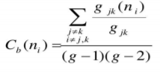
3. Closeness
   1. 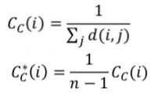

Using this top 20 nodes will be listed out. So anyone if in an emergency can reachc out to anyone of them for help.

There is also a visualization tool called GEPHI which we will be using for a proper see through of the project.

**DATASET USED**

a.The reference data set being used is taken from kaggle.

b.Our project is an innovative self created idea, not referenced from anywhere else. The justification of validity of need of such a project, lies in the immense time shortage and immediate action requirement during critical emergency times.

**HARDWARE AND SOFTWARE REQUIREMENTS**

A laptop/desktop with 4GB of ram along with a java 1.8 or higher , python idle 3.7 and networkx library.

# Tools used:

The only tool we have sed comprises of gephi graph visualization which consist of jdk home prompt and several python libraries.

# RUNNING CODE

import csv

import networkx as nx

from operator import itemgetter

import community

# Read in the nodelist file

with open('quakers_nodelist.csv', 'r') as nodecsv:

nodereader = csv.reader(nodecsv)

nodes = [n for n in nodereader][1:]

# Get a list of just the node names (the first item in each row)

node_names = [n[0] for n in nodes]

# Read in the edgelist file

with open('quakers_edgelist.csv', 'r') as edgecsv:

edgereader = csv.reader(edgecsv)

edges = [tuple(e) for e in edgereader][1:]

# Print the number of nodes and edges in our two lists

print(len(node_names))

print(len(edges))

G = nx.Graph() # Initialize a Graph object

G.add_nodes_from(node_names) # Add nodes to the Graph

G.add_edges_from(edges) # Add edges to the Graph

print(nx.info(G)) # Print information about the Graph

hist_sig_dict = {}

gender_dict = {}

birth_dict = {}

death_dict = {}

id_dict = {}

for node in nodes: # Loop through the list, one row at a time

hist_sig_dict[node[0]] = node[1]

gender_dict[node[0]] = node[2]

birth_dict[node[0]] = node[3]

death_dict[node[0]] = node[4]

id_dict[node[0]] = node[5]

nx.set_node_attributes(G, hist_sig_dict, 'historical_significance')

nx.set_node_attributes(G, gender_dict, 'gender')

nx.set_node_attributes(G, birth_dict, 'birth_year')

nx.set_node_attributes(G, death_dict, 'death_year')

nx.set_node_attributes(G, id_dict, 'sdfb_id')

for n in G.nodes(): # Loop through every node, in our data "n" will be the name of the person

print(n, G.node[n]['birth_year']) # Access every node by its name, and then by the attribute "birth_year"

density = nx.density(G)

print("Network density:", density)

fell_whitehead_path = nx.shortest_path(G, source="Margaret Fell", target="George Whitehead")

print("Shortest path between Fell and Whitehead:", fell_whitehead_path)

print("Length of that path:", len(fell_whitehead_path)-1)

print(nx.is_connected(G))

# Next, use nx.connected_components to get the list of components,

# then use the max() command to find the largest one:

components = nx.connected_components(G)

largest_component = max(components, key=len)

# Create a "subgraph" of just the largest component

# Then calculate the diameter of the subgraph, just like you did with density.

#

subgraph = G.subgraph(largest_component)

diameter = nx.diameter(subgraph)

print("Network diameter of largest component:", diameter)

triadic_closure = nx.transitivity(G)

print("Triadic closure:", triadic_closure)

degree_dict = dict(G.degree(G.nodes()))

nx.set_node_attributes(G, degree_dict, 'degree')

print(G.node['William Penn'])

sorted_degree = sorted(degree_dict.items(), key=itemgetter(1), reverse=True)

print("Top 20 nodes by degree:")

for d in sorted_degree[:20]:

print(d)

betweenness_dict = nx.betweenness_centrality(G) # Run betweenness centrality

eigenvector_dict = nx.eigenvector_centrality(G) # Run eigenvector centrality

# Assign each to an attribute in your network

nx.set_node_attributes(G, betweenness_dict, 'betweenness')

nx.set_node_attributes(G, eigenvector_dict, 'eigenvector')

sorted_betweenness = sorted(betweenness_dict.items(), key=itemgetter(1), reverse=True)

sorted_betweenness1 = sorted(eigenvector_dict.items(), key=itemgetter(1), reverse=True)

print("Top 20 nodes by betweenness centrality:")

for b in sorted_betweenness[:20]:

print(b)

print("Top 20 nodes by eigenvector centrality:")

for b in sorted_betweenness1[:20]:

print(b)

#First get the top 20 nodes by betweenness as a list

top_betweenness = sorted_betweenness[:20]

#First get the top 20 nodes by betweenness as a list

top_betweenness = sorted_betweenness1[:20]

#Then find and print their degree

for tb in top_betweenness: # Loop through top_betweenness

degree = degree_dict[tb[0]] # Use degree_dict to access a node's degree, see footnote 2

print("Name:", tb[0], "| Betweenness Centrality:", tb[1], "| Degree:", degree)

**RESULTS**

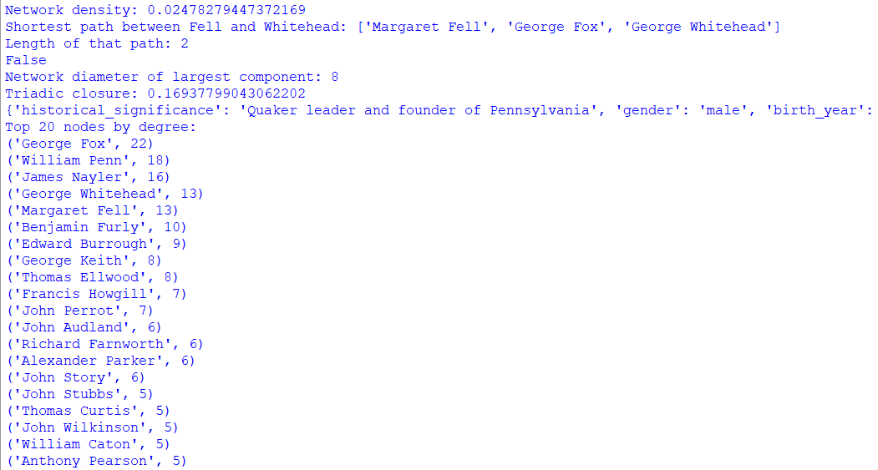

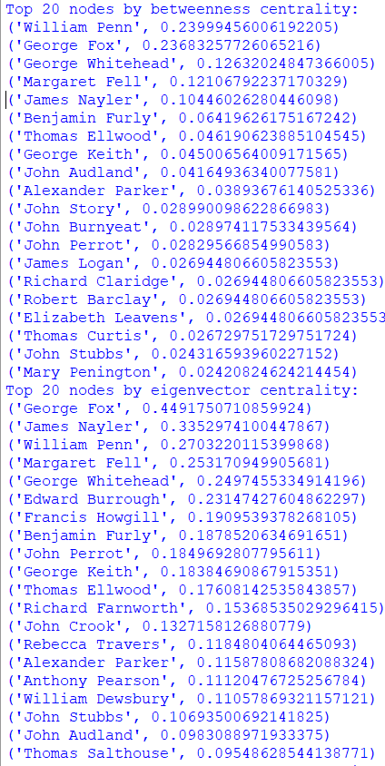

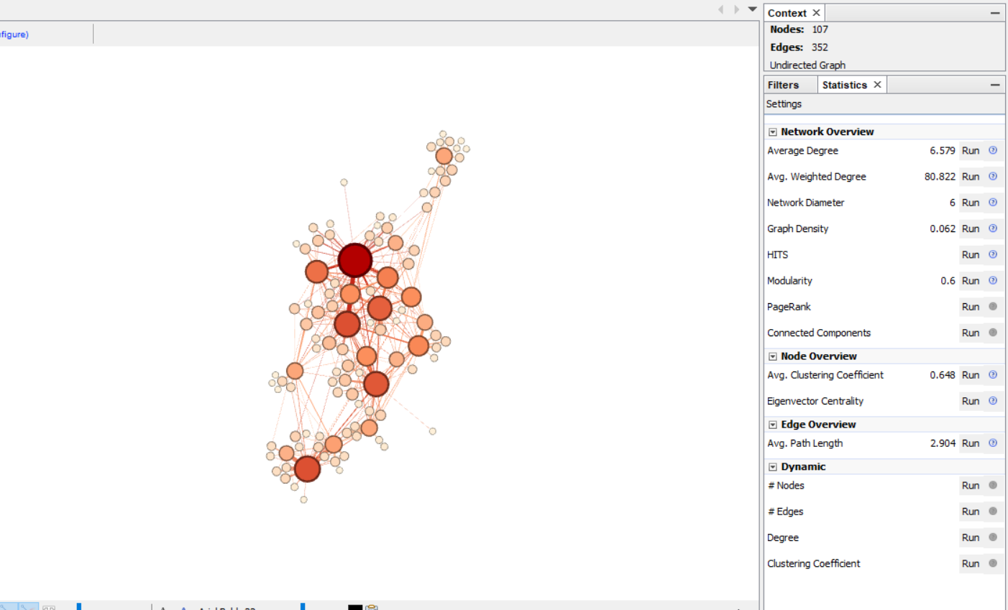

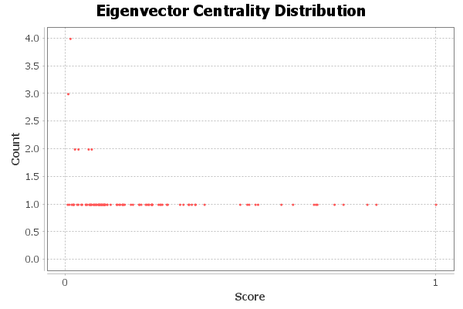

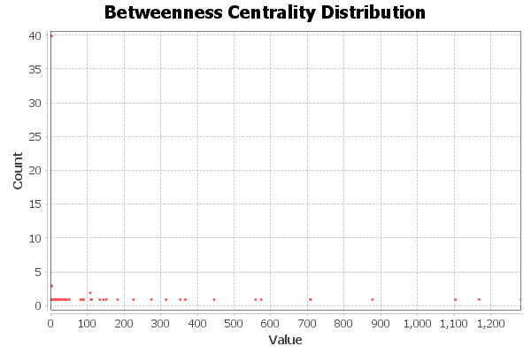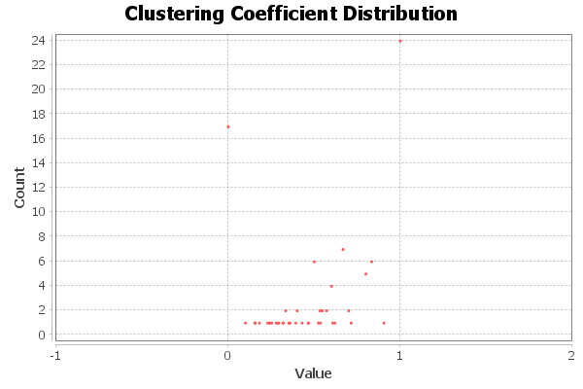

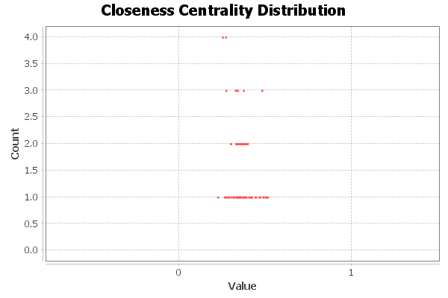

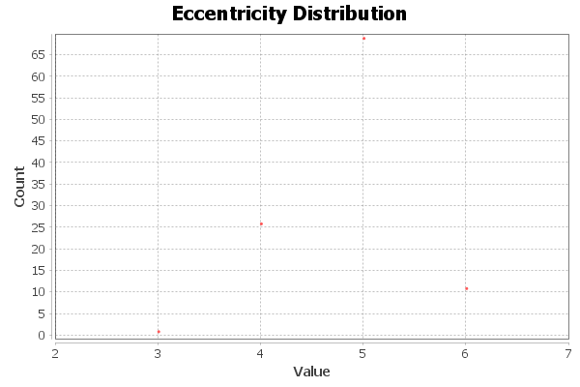

**Conclusion**

Through our project we can come to a conclusion that centrality measures can be used vastly for emergency purposes. The person will know whom to contact for immediate results.

This is done through different measurements like

1.Betweenness centrality

2.Eigen vector centrality

3.Network diameter

4.Graph density

5.Avg clustering coefficient

6.Avg path length

7.Triadic closure

8.Shortest path

The person will have the list of names within seconds and he/she can get help.

# References

1.https://snap.stanford.edu/data/roadNet-TX.html

2.www.kaggle.com

3.http://journals.sagepub.com/doi/10.1177/1745691612442904

4.https://ieeexplore.ieee.org/xpl/mostRecentIssue.jsp?punumber=7517494

5.https://ieeexplore.ieee.org/xpl/mostRecentIssue.jsp?punumber=7457420

6.https://journals.aps.org/pre/abstract/10.1103/PhysRevE.64.016132

7.https://www.journals.uchicago.edu/doi/abs/10.1086/228631